Update Sets in Service Now

Scenario-I

Update Set:Update set in service now is a container which captures the changes which we perform under one application.This captured changes can be converted to xml file format and can be imported in another developer instance to reflect the changes.

Note:Local Update Set should be created initially before starting the development work in an application.

Step-by-Step procedure to create local update sets.

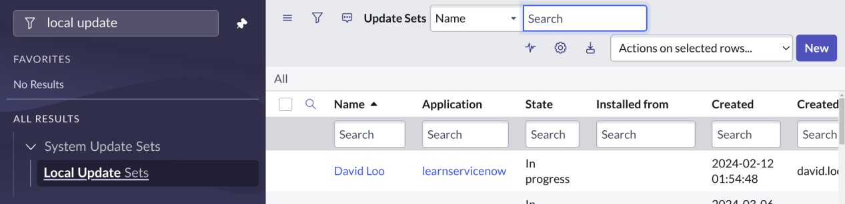

Click on New to create a new local update set

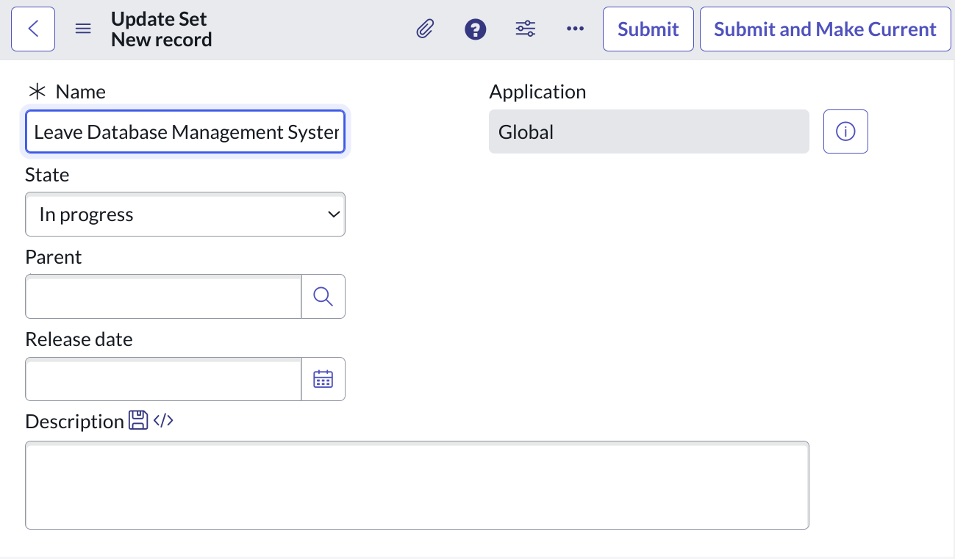

Here we can give

Name of the update set which should define the feature we are developing. Like for example leave request form in which it might capture form data.

State defines the current state of the update set which contains the following

. In progress
. Complete
. Ignore

If the update set is in Inprogress which means it is still in the state to capture the changes.

If the update set is in complete state then no furthur changes are captured in this set.
If the update set is in Ignore state then changes made will be ignored.

And finally if we click on submit and make current then the local update set will created under current selected custom application..or else if we click on simply submit then the update set will be created under global scope.

And this created update set will be the parent one.

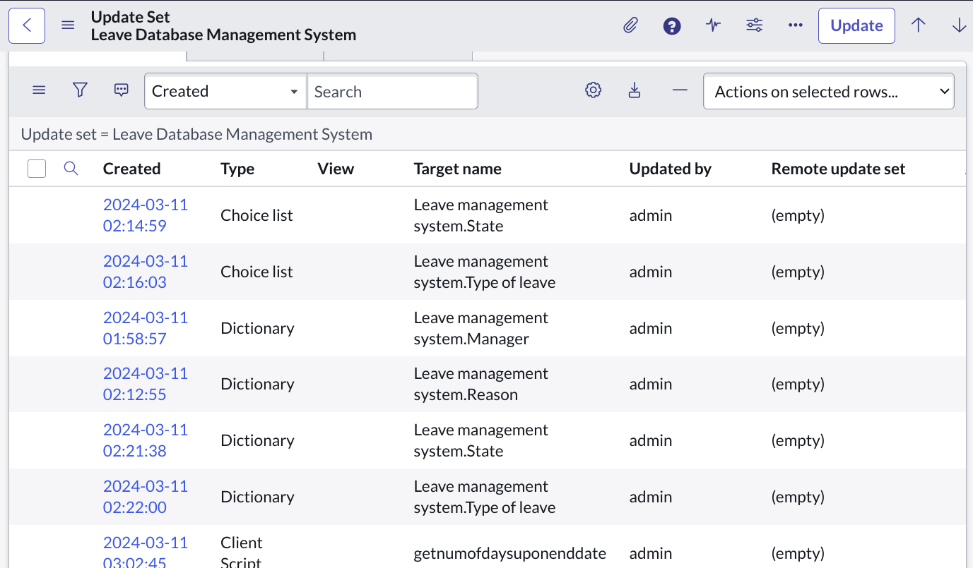

Here we can see the changes which we made and captured under these created update set.

Now if we want to commit these changes to another instance it may be developer/production instance ..then first we need to change the state of the update set to complete so that no furthur changes are captured.Now there is an option called export to xml in which our changes will be converted to xml format and the file will be downloaded in our local system.

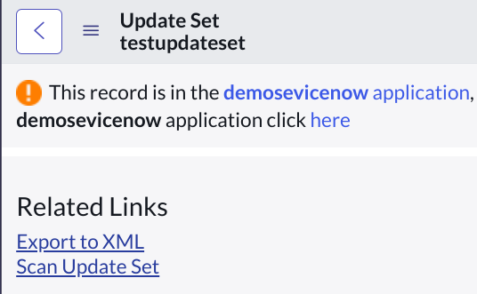

Now the next step is to import these xml file in the servicenow instance in which we want to commit the changes[in another developer/production instance].

Steps to Import and Commit the changes

- Click on Retrieved update sets under system update sets in the left side menu.
- There we can see an option called Import update set from xml.

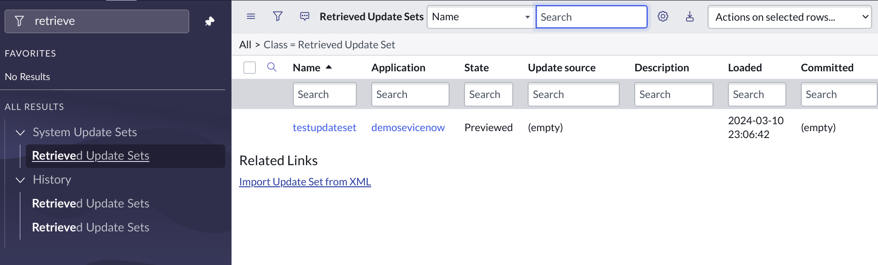

- If we click on these import update set from xml,it gives an option to choose file from device and upload the file.

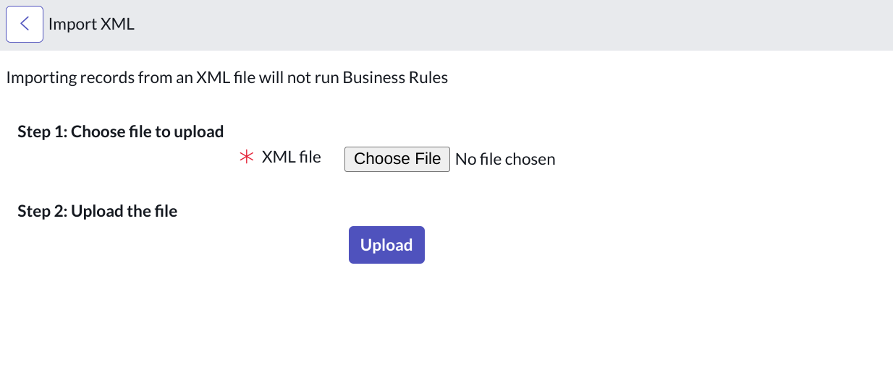

- If we click on upload then it review the changes which are present in the xml file and spots errors if any.

- And finally we have an option to commit update set ..once we click on it the changes will be commited and reflected on respective modules.

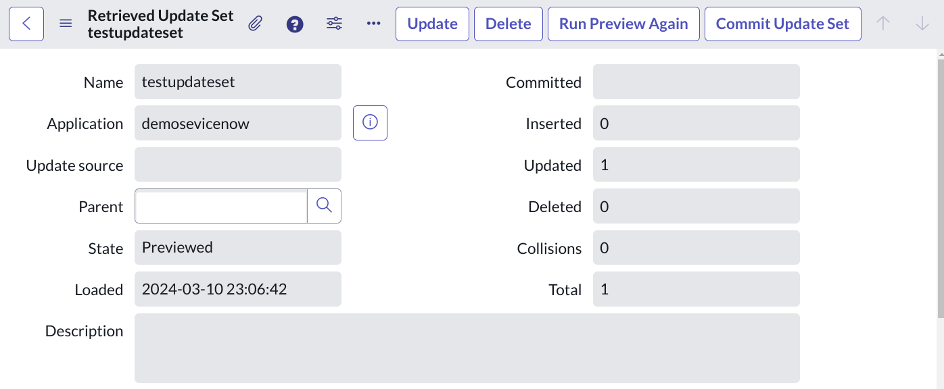

Scenario-II

If we have multiple local update sets in an instance, for suppose 50 0r 100 which defining some features that to be developed.

So in such case we come across parent-child update sets formally called Batch update sets.

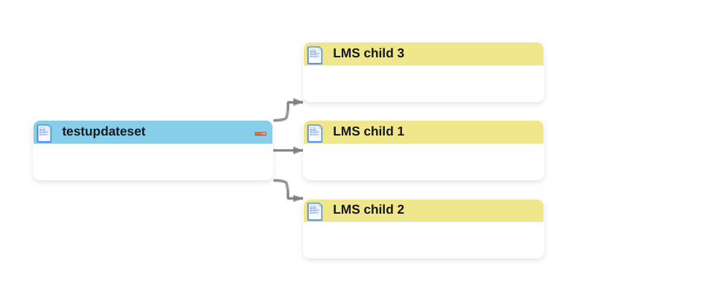

Similar procedure has we followed in update sets.But the change here is,all the child update sets which are created are mapped to parent update set.

So whenever we change the status of parent update set as completed then automatically the status of all the child update sets will be changed to completed,so that we can export all the changes done in the child data sets in one xml file itself.

And we can import these file in another developer instance and commit the changes.

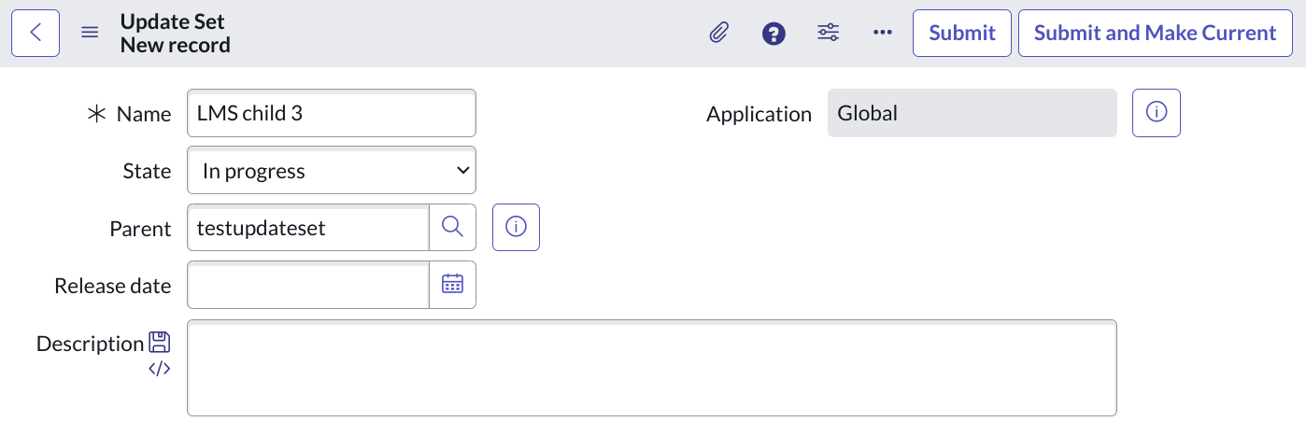

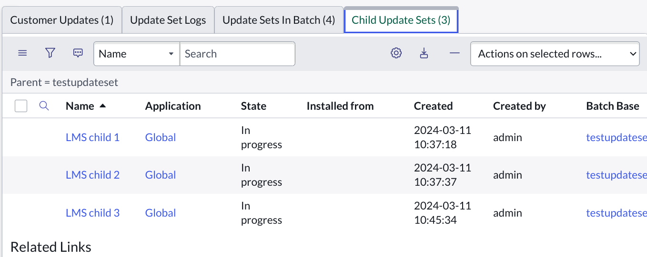

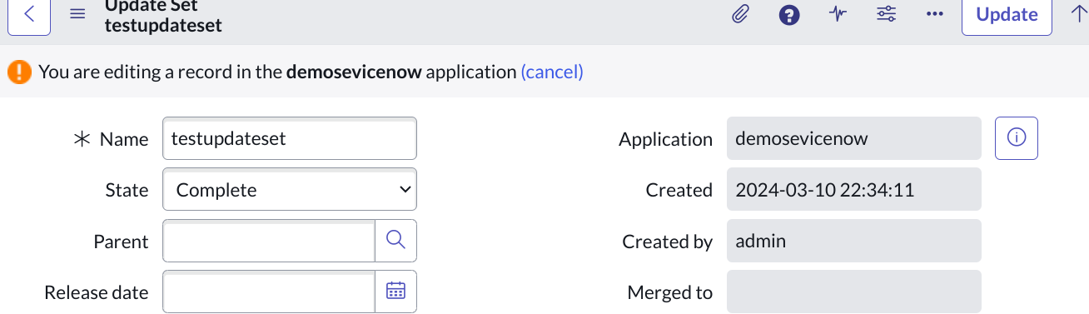

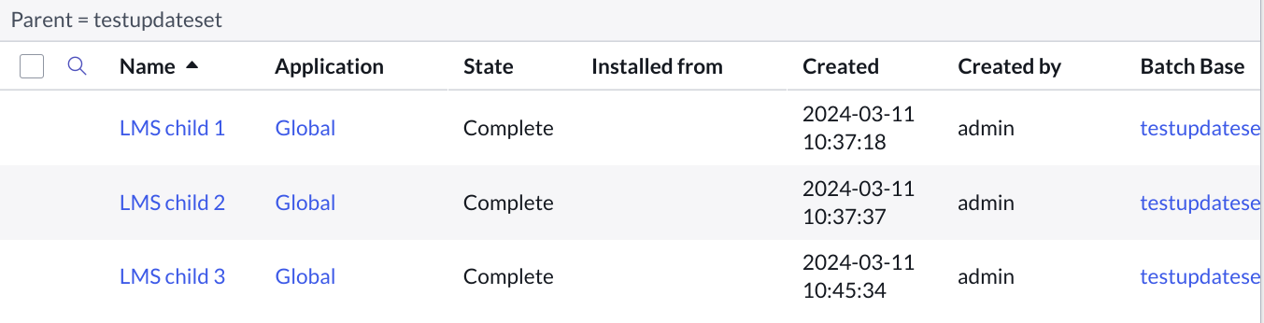

And finally some google research shows

